**SQL Assignment 1**

**List of tables and Rows:**

1. **Employee Table Fields-**
2. EmpId Int **(Primary Key)**,
3. FirstName varchar(15),
4. LastName varchar(15),
5. Salary Int,
6. Leaves Int,
7. DateBirth Date,
8. DateJoining date,
9. OverTimes Int,
10. DepartmentId Int **(Foreign Key),**
11. AddressId Int **(Foreign Key)**
12. **Address Table Fields-**
    1. AddressID Int **(Primary Key)**,
    2. AddressLine1 varchar(50),
    3. AddressLine2 varchar(50),
    4. City varchar(20),
    5. Region varchar(20),
    6. Country varchar(20),
    7. PinCode Int,
    8. AddressTypeID Int **(Foreign Key)**
13. **Department Table Fields-**
    1. DepartmentId Int **(Primary Key)**,
    2. DeptName varchar(40)
14. **AddressTypes Table Fields-**
    1. AddressTypeId Int **(Primary Key),**
    2. AddressType varchar(50)
15. **Sales Table Fields-**
    1. CutomerId Int **(Primary Key),**
    2. Name varchar(30),
    3. OrderId Int **(Foreign Key)**,
    4. Email nvarchar(50),
    5. SalesPersonId Int **(Foreign Key)**,
    6. ProductId Int **(Foreign Key)**
16. **Orders Table Fields-**
    1. OrderNumber Int,
    2. OrderID Int (**Primary Key)**,
    3. ProductName varchar(30),
    4. OrderDate datetime,
    5. ShippingDate datetime,
    6. DeliveryStatus varchar(20),
    7. PaymentMode varchar(20),
    8. Quantity Int
17. **Products Table Fields-**
    1. ProductID Int **(Primary Key),**
    2. Product varchar(30),
    3. Price Int
18. **SalesPerson Table Fields-**
    1. SalesPersonID Int **(Primary Key)**,
    2. FirstName varchar(15),
    3. LastName varchar(15),
    4. SalesNumber Int,
    5. SalesTarget Int,
    6. SaleStatus varchar(10)
19. Print the names of the employees who have highest no of leaves.

**Query** : **Select * from Employee order by Leaves desc;**

1. Print the names of the employees that took the second highest leaves get the 2nd highest no of leaves.

**Query** : **Select Top(1) * from Employee where Leaves < (Select max(Leaves) as MaxLeaves from Employee) order by Leaves desc;**

1. Print nth THTHthhighest salary.

**Query** : **SELECT TOP(1) Salary FROM ( SELECT DISTINCT TOP(5) Salary FROM Employee ORDER BY salary DESC ) AS Nth_Sal ORDER BY salary;**

1. Print Name of the employee, Department name, StartDate, EndDate - Ordered by Employee, StartDate ascending.

**Query** : **SELECT a.EmpId, a. FirstName, a.LastName, a.DateJoining, a.Salary , b.DeptName FROM (Employee a**

**INNER JOIN Department b**

**ON a.DepartmentId = b.DepartmentId)**

**ORDER BY a.DateJoining;**

1. Print the Employees that are assigned to more than one department.
2. Print the number of employees that are not assigned to any deparment.

**Query** : **Select * from Employee Where DepartmentId is null;**

1. Print the number of employees by their shift [Number of employees working day, evening, and night].

**Query** : **Select EmployeeShift, count(EmployeeShift) as EmpCount from Employee**

**GROUP BY EmployeeShift;**

1. Print Number of Emplyoees by CountryRegionName.

**Query** : **Select Region, count(Region) as RegionCount from Address group by Region;**

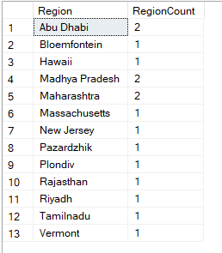

1. Print the name of the CoutryRegion with the highest number of employees.

**Query** : **Select TOP(1) Country, count(Country) as CountryCount from Address group by Country order by CountryCount desc;**

1. Print the employee with their home address detail.

**Query** : **Select a.FirstName, a.LastName, c.AddressType, b.AddressLine1, b.AddressLine2, b.City, b.Country, b.PinCode**

**FROM Employee a**

**JOIN Address b**

**ON a.AddressId = b.AddressID**

**JOIN AddressTypes c**

**ON b.AddressTypeID = c.AddressTypeId**

**WHERE c.AddressType LIKE '%HOME%';**

1. First Name, Last name, AddressType = Home, Line1, Line2, City, State (I want the name of the state here), Postal Code and Country.

**Query** : **Select a.FirstName, a.LastName, CONCAT_WS(' , ', c.AddressType, b.AddressLine1, b.AddressLine2, b.City, b.Region, b.Country, b.PinCode) as EmpAddress**

**FROM Employee a**

**JOIN Address b**

**ON a.AddressId = b.AddressID**

**JOIN AddressTypes c**

**ON b.AddressTypeID = c.AddressTypeId;**

1. Print the number of employees that don't have shipping address.

**Query** : **Select count(AddressTypeId) as NoShippingAdd from Address**

**WHERE AddressTypeID NOT IN (4, 6, 7, 8);**

1. Print the number of employees that have Home + Billing addresses.

**Query** : **Select count(AddressTypeID) as HomeAndBilling from Address**

**Where AddressTypeID NOT IN (3, 5, 7, 8);**

1. Print the count of employees that are living in Texas state.

**Query** : **Select count(Country) as Texas_Count from Address where Country = 'Texas';**

1. Get the customers and their Sale value (total due).

**Query** : **Select a.CutomerId, a.Name, b.ProductName, b.DeliveryStatus, b.Quantity, c.Price, (b.Quantity*c.Price) as Total**

**FROM ((Sales a**

**JOIN Orders b**

**ON a.OrderId = b.OrderID)**

**JOIN Products c**

**ON b.ProductName = c.Product);**

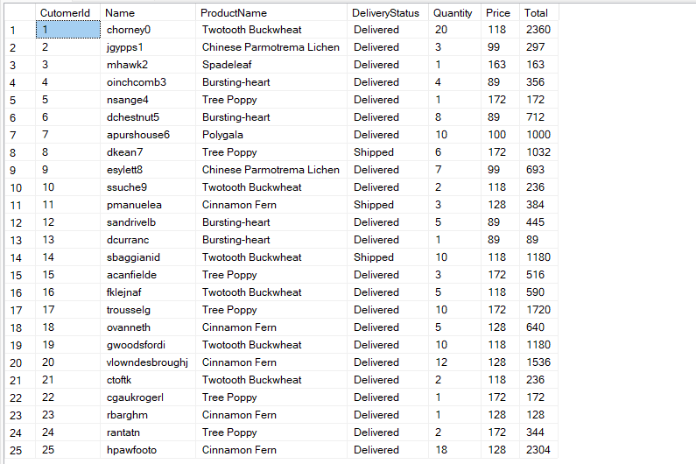

1. Get the names of the salespersons that did the highest sale.

**Query** : **Select FirstName, LastName, SalesNumber from SalesPerson Where SalesNumber = (Select max(SalesNumber) from SalesPerson);**

1. Number of sales by Online vs non-online.

**Query** : **Select PaymentMode, COUNT(PaymentMode) as SaleNumber From Orders group by PaymentMode;**

1. Number of sales by their status.

**Query** : **Select DeliveryStatus, Count(DeliveryStatus) as DeliveryStatus**

**FROM Orders Group By DeliveryStatus;**

1. Print the number of customers by Product.

**Query** : **Select p.Product, count(p.Product) as CustomerNumber**

**FROM Sales s**

**JOIN Products p**

**ON s.ProductId = p.ProductID**

**GROUP BY p.Product;**

1. Print the most popular product.

**Query** : **Select TOP(1) p.Product, count(p.Product) as TotalProductSold**

**FROM Sales s**

**JOIN Products p**

**ON s.ProductId = p.ProductID**

**GROUP BY p.Product**

**ORDER BY TotalProductSold desc;**

1. Print the products by their revenue.

**Query** : **Select QTY.ProductName, QTY.QtySold, Pro.Price, QTY.Revenue**

**FROM (**

**Select o.ProductName, SUM(Quantity) as QtySold, SUM(o.Quantity*p.Price) AS Revenue**

**From Orders o**

**JOIN Products p**

**ON o.ProductName = p.Product**

**GROUP BY o.ProductName**

**) AS QTY**

**JOIN Products pro ON Qty.ProductName = Pro.Product;**

